Submission of ER Diagram, Class Diagram ,Object Diagram

ER Diagram

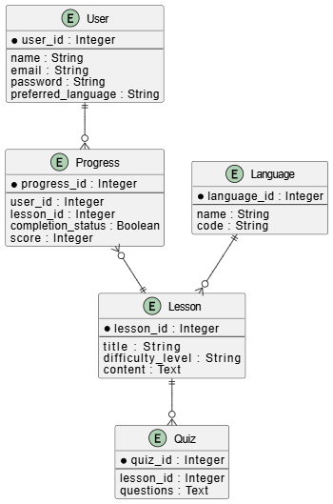

Class Diagram

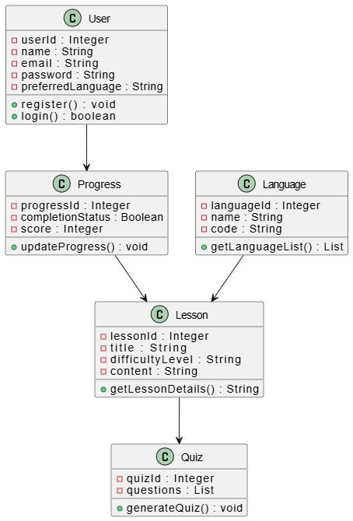

Object Diagram

